Project – 3

Git Clone:



Docker:

Dockerized the application by creating Dockerfile and build the images by using the command:

docker build -t trend-app1 .

docker run -itd –name trend-app1container -p 3001:3000 trend-app1

docker images and containers

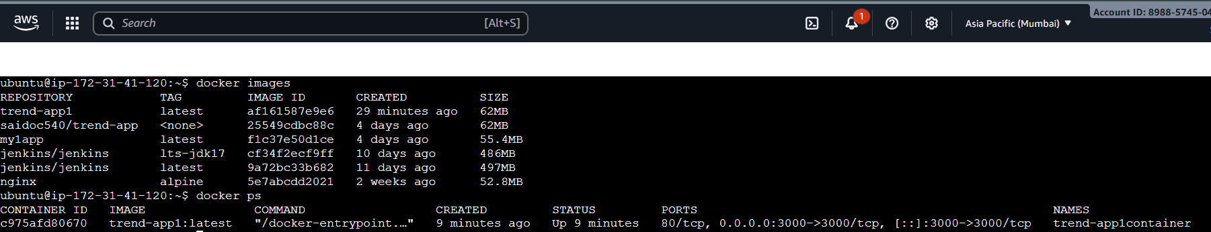

Output

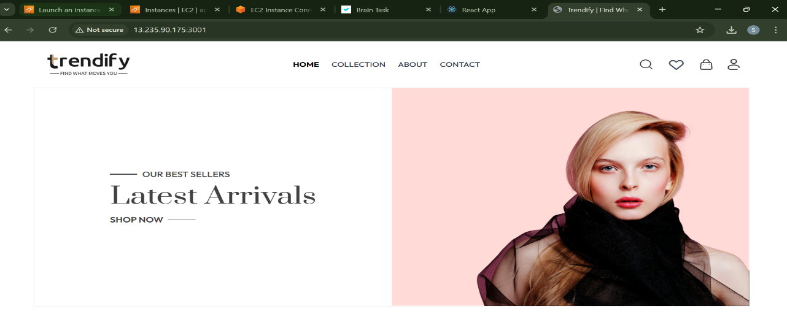

Terraform:

* Instead of manually creating a VPC, EC2, or IAM users, we use **Terraform**, which lets us write all the resources as code. With a few commands like terraform init, terraform plan, and
* init prepares Terraform, plan shows what it will do,

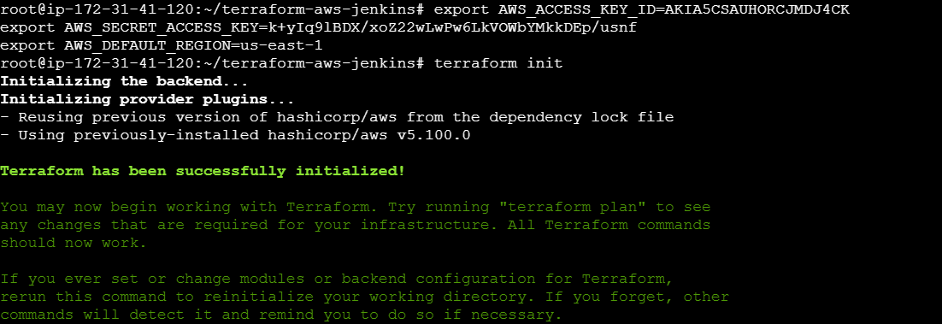

* Terraform Plan

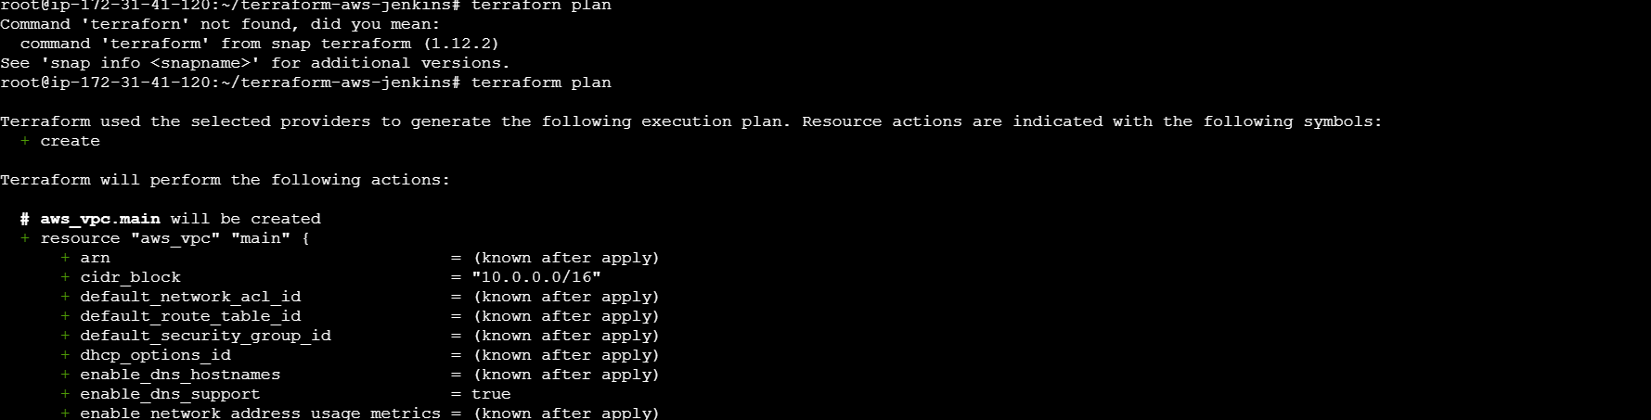

* apply actually provisions the resources.

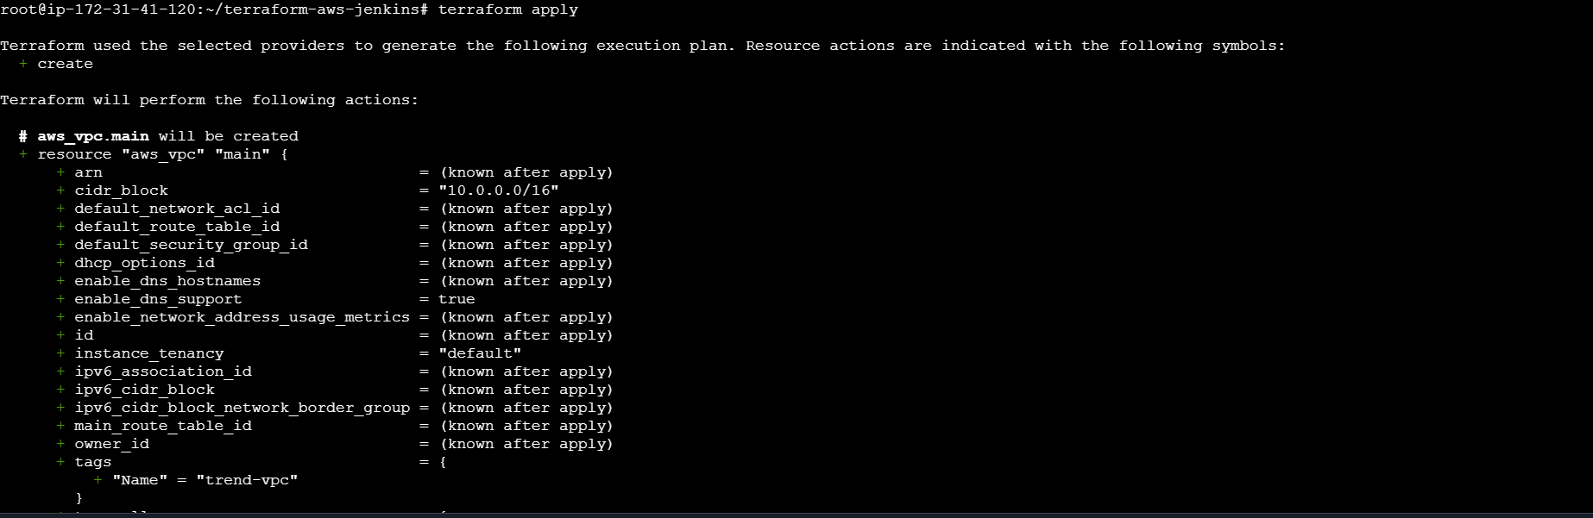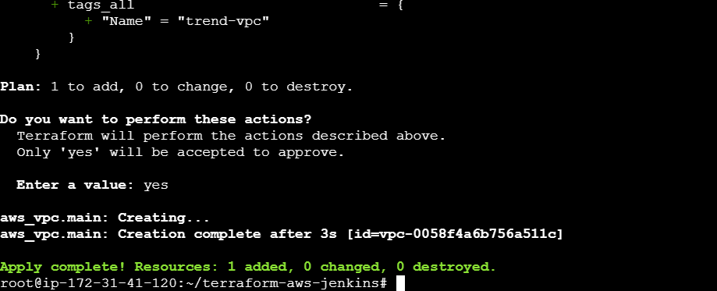

DockerHub:

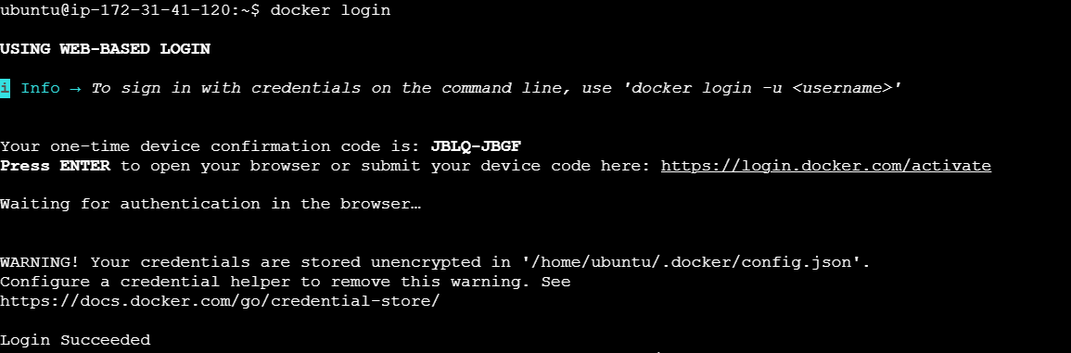

Tagged and pushed the images:

* docker tag trend-app:latest <saidoc540>trend-app:latest
* docker push <saidoc540>/trend-app:latest

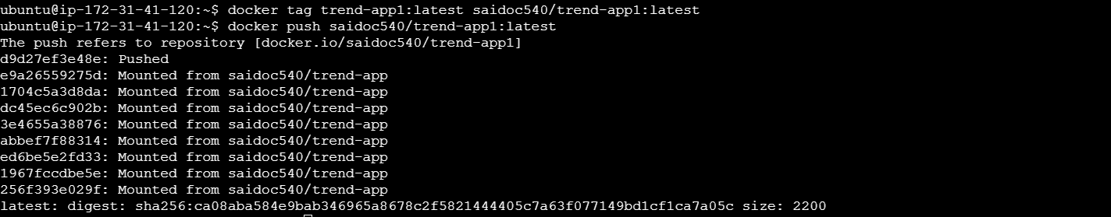

Kubernetes:

* Setup Kubernetes in AWS EKS and Confirm EKS cluster is running.



* deployment and service YAML files.

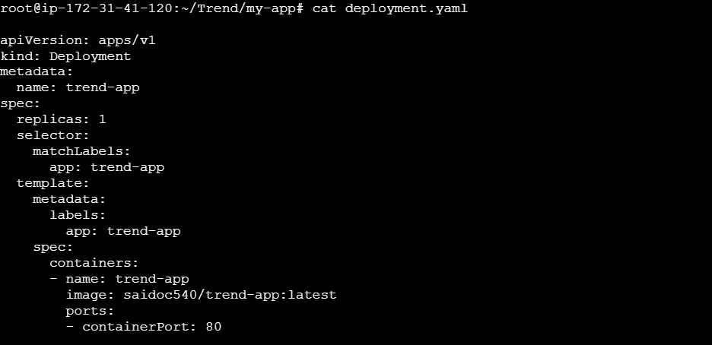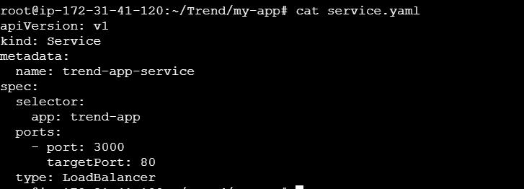

Deployed using kubectl via Jenkins.

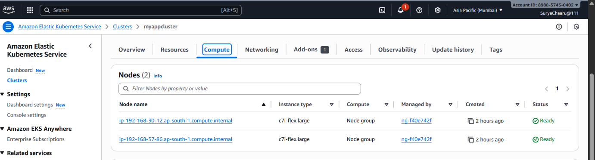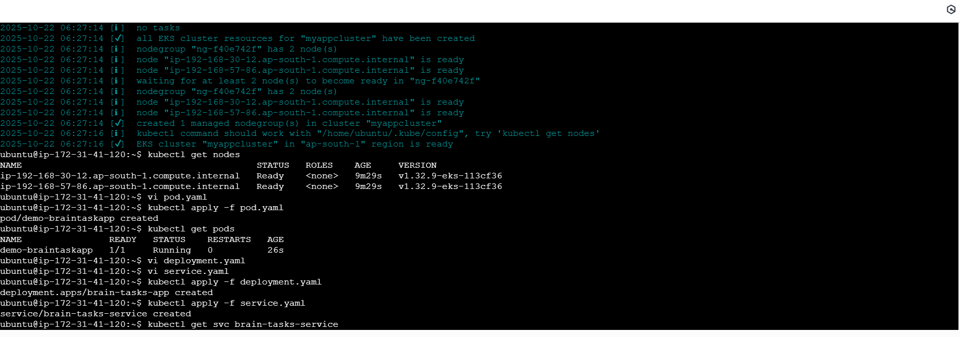

* **Commands used**
* kubectl apply -f k8s/deployment.yaml
* kubectl apply -f k8s/service.yaml
* kubectl get pods
* kubectl get svc

Version Control:

* .gitignore and .dockerignore files

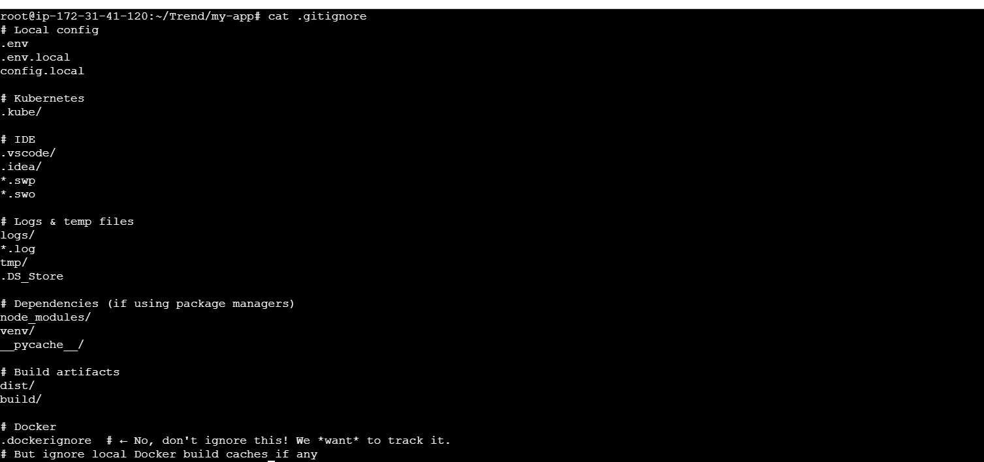

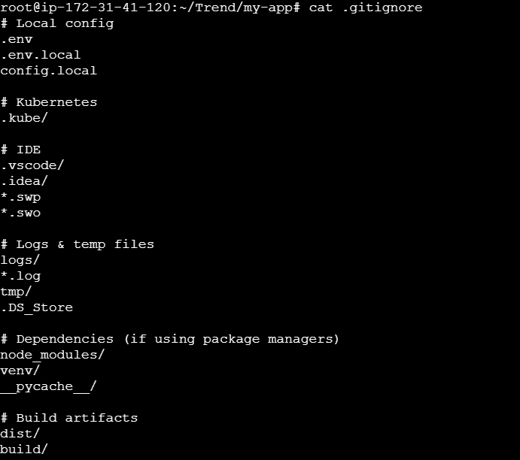

git add .

git commit -m "Initial commit with Docker & Kubernetes setup"

it remote add origin https://github.com/your-username/your-repo.git

it remote add origin https://github.com/Bhuvisai22/your-repo.git

git remote add origin https://github.com/Bhuvisai22/your-repo.git

git push -u origin main

git remote add origin <https://github.com/Bhuvisai22/project-3.git>

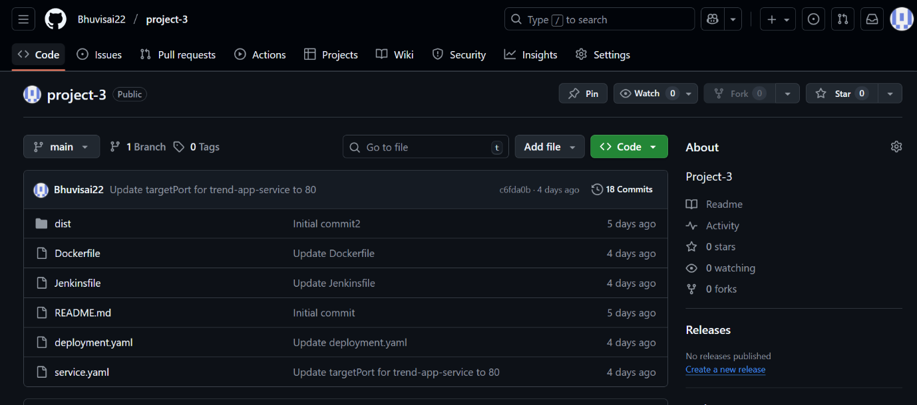

Jenkins:

Installed Jenkins

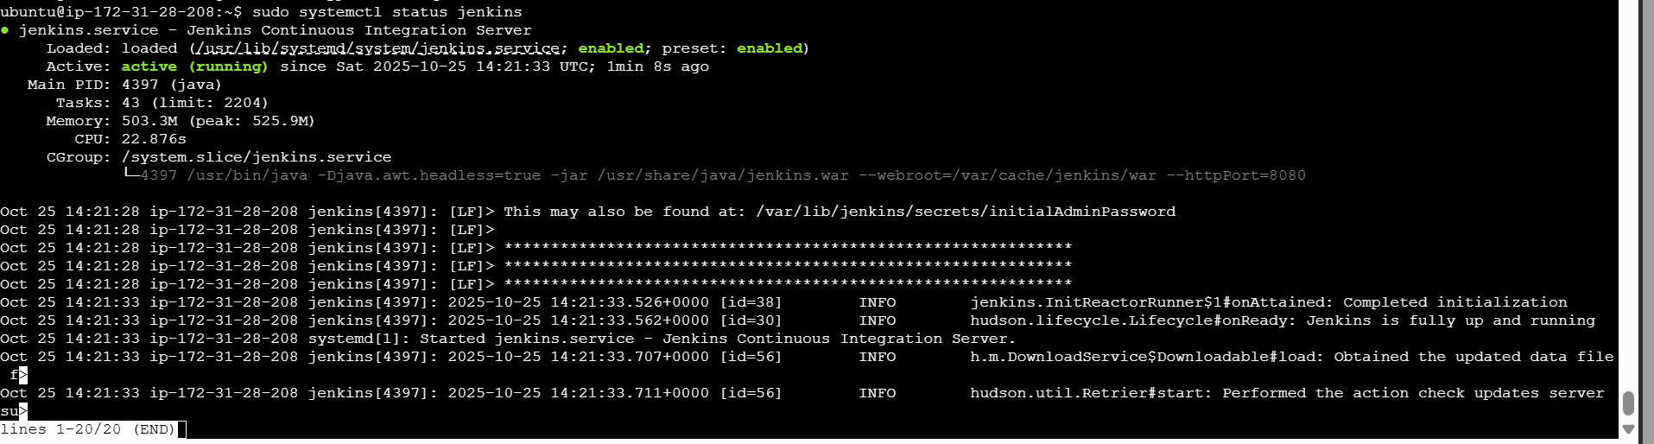

Configured to GITHUB 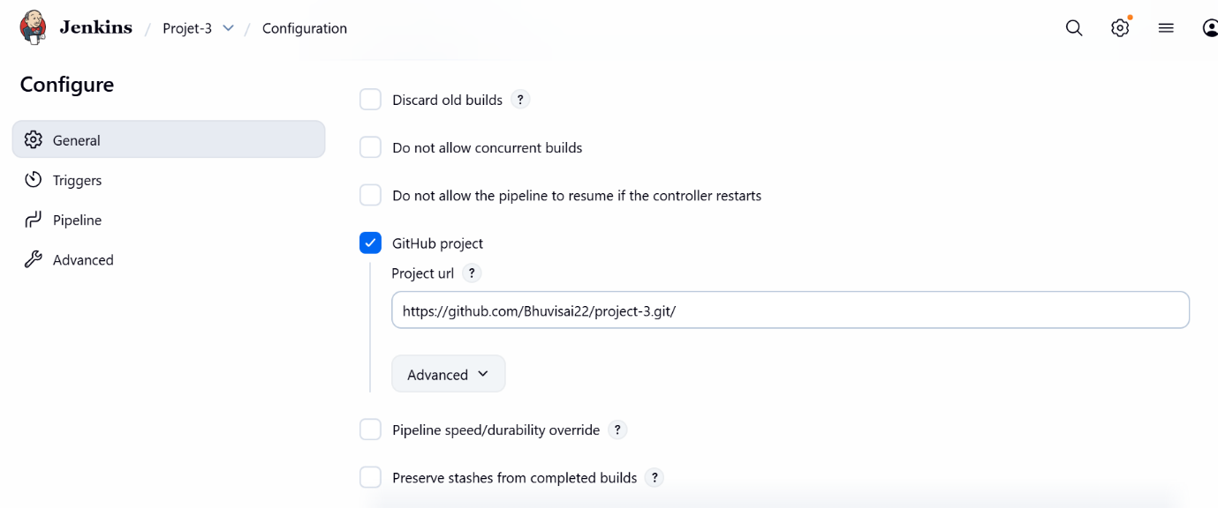 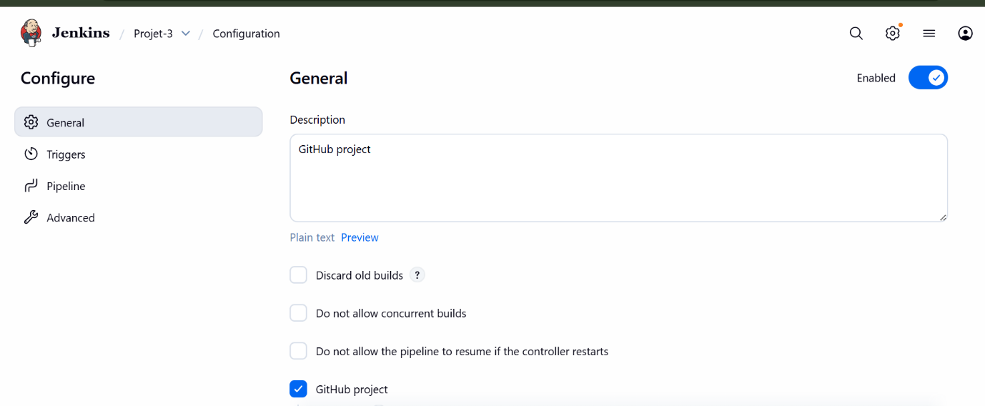

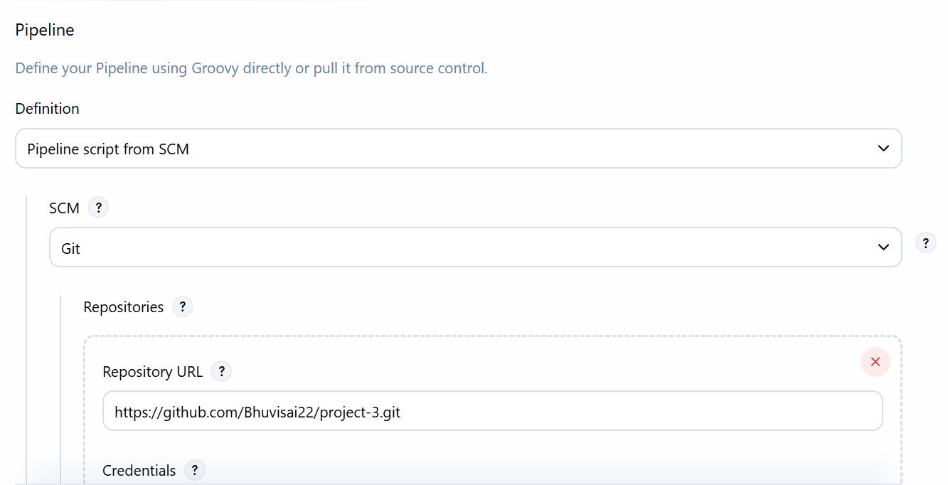

Deployed the application

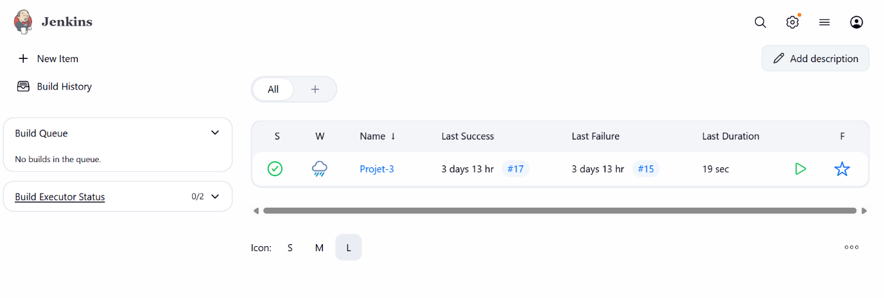

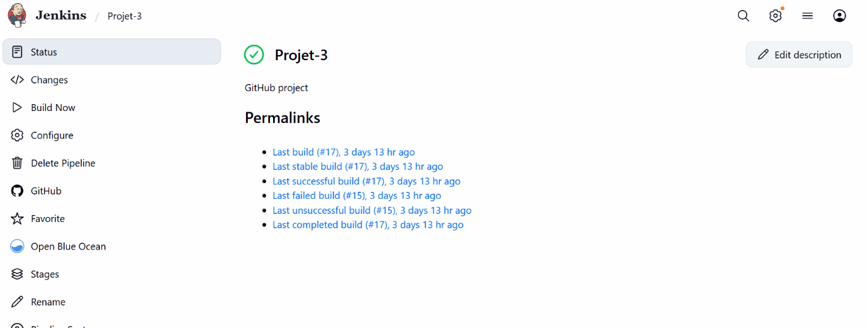

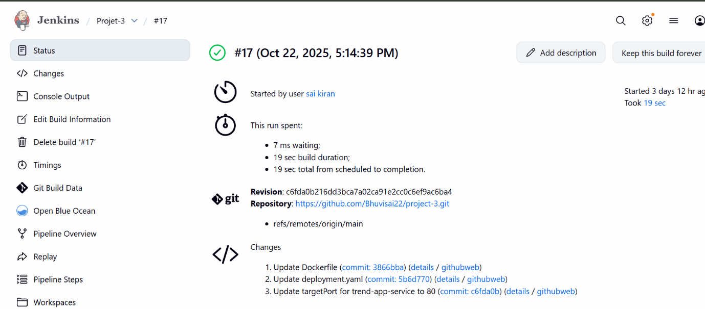

Monitoring:

Setup a monitoring system to check the health of the cluster or application (opensource) is highly appreciable.

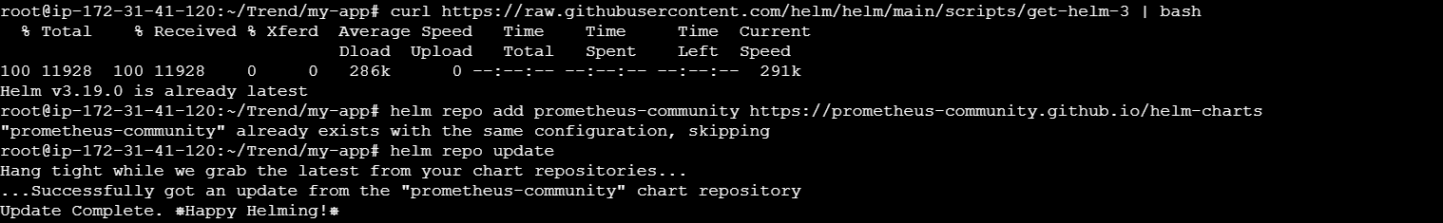

Commands used to monitor

